Dis-Am,C-Taino-Fertility Figure-Puerto Rico

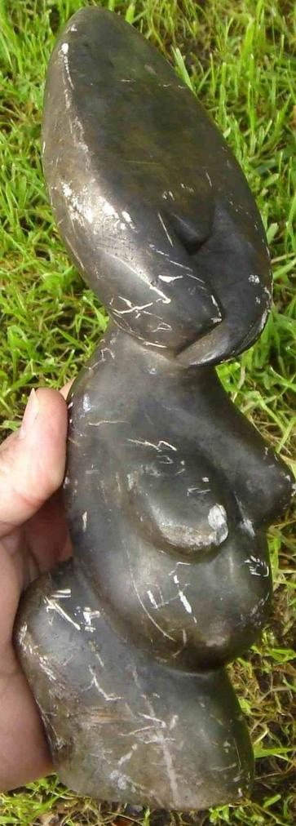 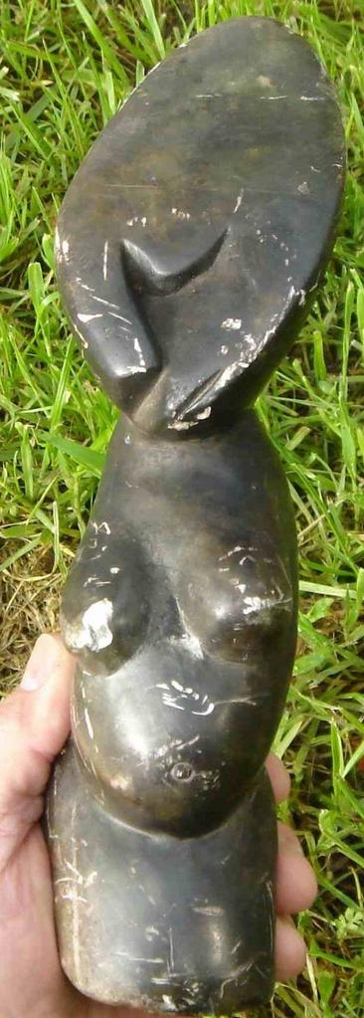

|  |  |
| --- | --- |
| ORDER DATEMar 28, 2016 | ORDER TOTAL  US $124.00  + US $14.00  shipping  **Order FERTILITY-EFFIGY, North Western PUERTO RICO, 19th Century Find** [Leave feedback - ORDER DATE Mar 28, 2016](http://feedback.ebay.com/ws/eBayISAPI.dll?LeaveFeedbackShow&useridto=saltrento&transactID=0&item=172142340886&_trksid=p2057872.m2749.l2665)[View order details](http://payments.ebay.com/ws/eBayISAPI.dll?ViewPaymentStatus&transId=0&itemid=172142340886&_trksid=p2057872.m2749.l2673) - ORDER DATE Mar 28, 2016  [More actions - ORDER DATE Mar 28, 2016](http://www.ebay.com/myb/PurchaseHistory) |

1 item sold by [saltrento](http://www.ebay.com/usr/saltrento?_trksid=p2057872.m2749.l2754)

|  |  |  |
| --- | --- | --- |
| [FERTILITY-EFFIGY, North Western PUERTO RICO, 19th Century Find](http://www.ebay.com/itm/172142340886?_trksid=p2057872.m2749.l2649&ssPageName=STRK%3AMEBIDX%3AIT)  ( 172142340886 )  Delivered on Thu, Mar 31  Tracking number: [**Tracking number**9405509699938339648795](javascript:;)  [Add note](javascript:;) | ITEM PRICE:  US $124.00 |  |

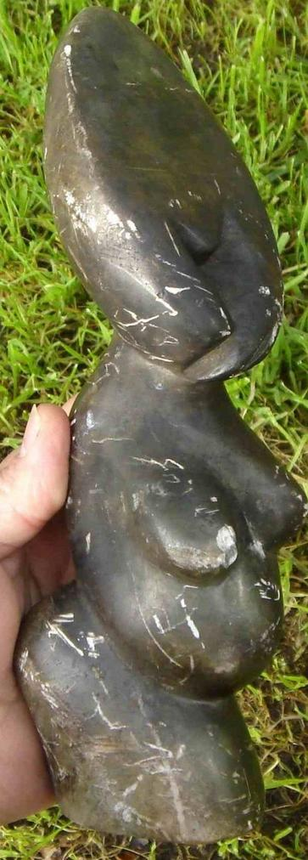 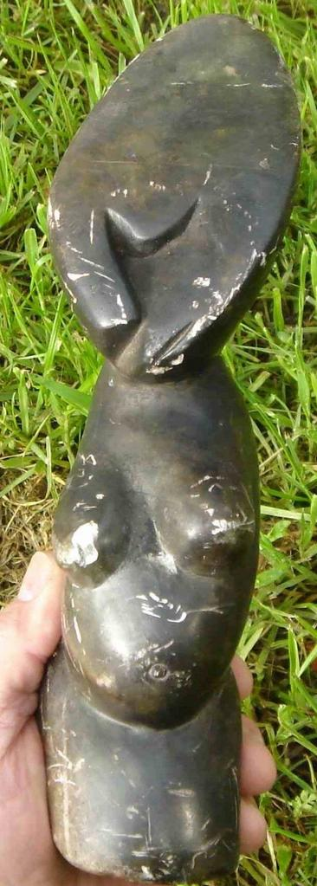

|  |  |
| --- | --- |
| ORDER DATEMar 28, 2016 | ORDER TOTAL  US $124.00  + US $14.00  shipping  **Order FERTILITY-EFFIGY, North Western PUERTO RICO, 19th Century Find** [Leave feedback - ORDER DATE Mar 28, 2016](http://feedback.ebay.com/ws/eBayISAPI.dll?LeaveFeedbackShow&useridto=saltrento&transactID=0&item=172142340886&_trksid=p2057872.m2749.l2665)[View order details](http://payments.ebay.com/ws/eBayISAPI.dll?ViewPaymentStatus&transId=0&itemid=172142340886&_trksid=p2057872.m2749.l2673) - ORDER DATE Mar 28, 2016  [More actions - ORDER DATE Mar 28, 2016](http://www.ebay.com/myb/PurchaseHistory) |

1 item sold by [saltrento](http://www.ebay.com/usr/saltrento?_trksid=p2057872.m2749.l2754)

|  |  |  |
| --- | --- | --- |
| [FERTILITY-EFFIGY, North Western PUERTO RICO, 19th Century Find](http://www.ebay.com/itm/172142340886?_trksid=p2057872.m2749.l2649&ssPageName=STRK%3AMEBIDX%3AIT)  ( 172142340886 )  Delivered on Thu, Mar 31  Tracking number: [**Tracking number**9405509699938339648795](javascript:;)  [Add note](javascript:;) | ITEM PRICE:  US $124.00 |  |